Project 3 Written Report
April Baik
Although I am personally not a big fan of baseball, most of my close friends in Korea are huge fans of baseball. Whenever we meet, they often talk about the baseball game they watched the day before. Also, I even went to a professional baseball game in Korea with them once. They showed me who their favorite players are, which players are famous, and which players perform the best. As I listened to them, I became curious whether the performance of the player or their fame really matters to their salary, if it does, how much it affects their salary. Since our Project 3 uses the Lahman data, I thought this was the perfect topic for my Project.
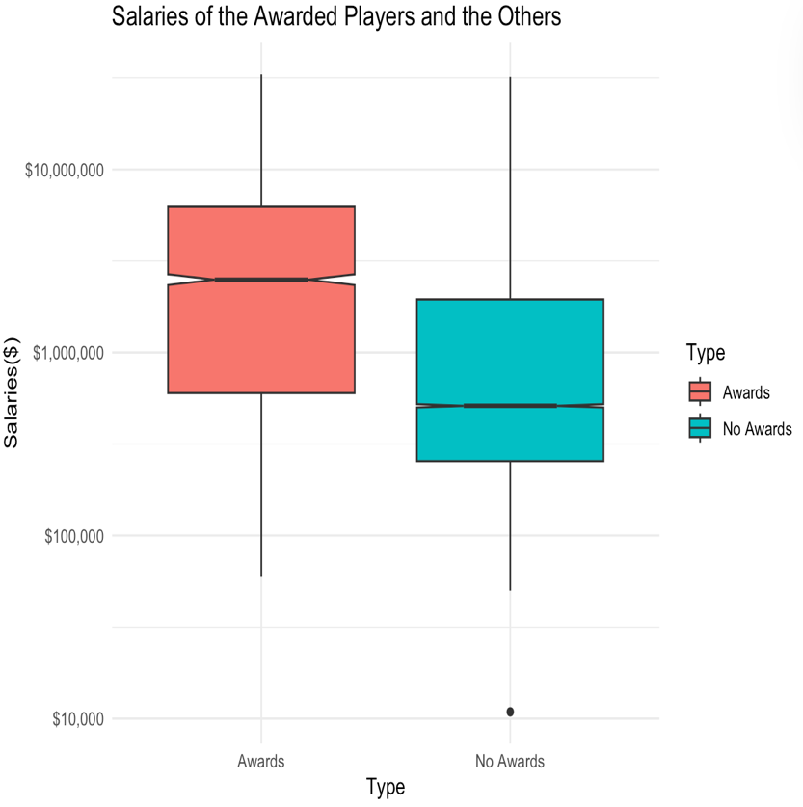
Relating to my question, for Project 3, I decided “Do players who received awards have higher salaries than the other players?” to be my topic. I thought that the award data was adequate for the benchmark, differentiating players who perform well and who do not. I gathered the data of the players, their awards, and their salaries from the Lahman database, and created a boxplot of the Salaries of the Awarded Players and the Players that did not receive an award.
From the graphic, we can see that the graphic of the awarded players is paid more, having a median of 2.5 million, while the median of the players who were not awarded has a median of 511000, which is five times smaller than the awarded players. The ANOVA shows that whether the player is awarded or not has a statistically significant effect on the salaries of the players (p < 0.001). We are 95% confident that the players who received awards earn between 4.29 million and 4.53 million, and the players who did not receive awards earn between 1.75 million and 1.84 million.
In conclusion, this project was meaningful to me, getting to know more about baseball games. It was interesting to see the graphics and table, which show the strong demand for the awarded layers baseball. This reflects how the sports field is competitive and fierce. I was surprised by the vast difference between the salaries of the awarded players and others. This helped me improve my understanding of baseball and how the individual player’s performance is also important while they play the game as a team.

